

Posts and Telecommunications Institute of Technology

ASSIGNMENT 2
INTELLIGENT SYSTEM DEVELOPMENT

Lecturer | : TRẦN ĐÌNH QUẾ
Student | : MAI ANH TUẤN ANH
Student ID | : B23DCCE005
Class | : E23CNPM02

Hà Nội, August 2026

A. Application 1 — Diabetes Prediction
1 Problem Description
The objective of this application is to predict whether a patient is diagnosed with diabetes using demographic, lifestyle, medical-history, and clinical health indicators. The target variable is diagnosed_diabetes , where 0 represents No Diabetes and 1 represents Diabetes. The task is therefore formulated as a binary classification problem.
Let $X$denote the patient features and $y$denote the target:
$$X=\text{patient features} \\ y=\text{diagnosed}\text{_}\text{diabetes}$$
For one patient, the input is represented as:
$$x_{i}={\left[x_{i1} , x_{i2} , … , x_{id}\right]}^{T}∈R^{d}$$
and the complete dataset can be represented as:
$$X∈R^{N×d}.$$
The objective is to learn a function
$$f:X→y$$
that can assign the appropriate diabetes class to an unseen patient.
2 Kaggle Dataset
The selected dataset is the Diabetes Health Indicators Dataset, obtained from Kaggle:
Kaggle URL:
https://www.kaggle.com/datasets/mohankrishnathalla/diabetes-health-indicators-dataset
The dataset contains approximately 100,000 patient records and includes demographic, lifestyle, medical-history, and clinical health indicators. Representative variables include age, gender, ethnicity, education, income, employment status, smoking status, physical activity, BMI, blood pressure, cholesterol, glucose, insulin, and HbA1c.
The original dataset contains 31 columns. For the predictive task, diagnosed_diabetes is used as the target. Variables potentially derived from diabetes status, particularly diabetes_stage and diabetes_risk_score, are excluded from the model input to reduce the risk of target leakage.
Dataset summary
Item | Value
Dataset | Diabetes Health Indicators Dataset
Source | Kaggle
Observations | 100,000
Original columns | 31
Predictive features | 28
Target | diagnosed_diabetes
Task | Binary classification
The final 28 predictive features comprise 22 numerical variables and 6 categorical variables.
Feature groups
The selected variables represent several aspects of the patient's health profile.
Feature group | Examples
Demographic | age, gender, ethnicity, education_level, income_level, employment_status
Lifestyle | smoking_status, alcohol_consumption_per_week, physical_activity_minutes_per_week, diet_score, sleep_hours_per_day, screen_time_hours_per_day
Medical history | family_history_diabetes, hypertension_history, cardiovascular_history
Anthropometric | bmi, waist_to_hip_ratio
Vital signs | systolic_bp, diastolic_bp, heart_rate
Lipid profile | cholesterol_total, hdl_cholesterol, ldl_cholesterol, triglycerides
Metabolic | glucose_fasting, glucose_postprandial, insulin_level, hba1c

3. Data Understanding
The raw CSV was loaded into a Pandas DataFrame and inspected through its shape, schema, descriptive statistics, missing-value counts, duplicate counts, and target distribution.
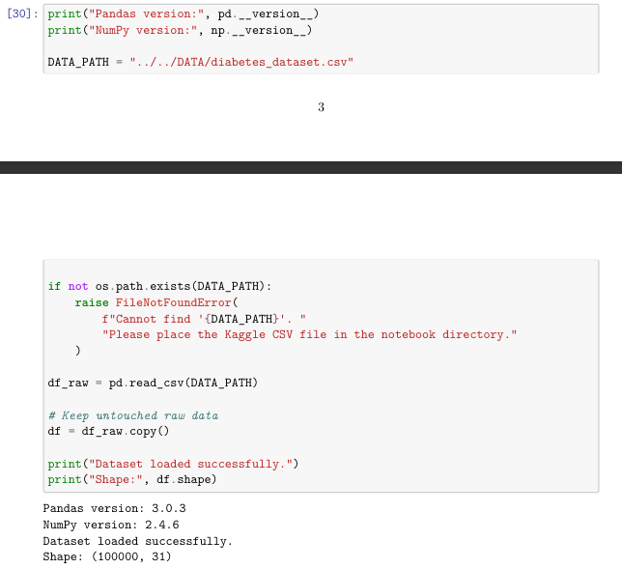
The original dataset has:
$$100,000×31$$
entries. After removing the target and two variables considered unsuitable for prediction because of their relationship with diabetes status, the predictive matrix contains:
$$X∈R^{100000×28}.$$
The dataset contains numerical and categorical variables, requiring different preprocessing strategies before model training.

Target distribution
The target contains:
+ 40,002 No Diabetes observations;
+ 59,998 Diabetes observations.
Thus, approximately 40% of the records belong to class 0 and 60% belong to class 1 => The classes are therefore not perfectly balanced, which justifies the use of class_weight="balanced" in several classifiers and the use of class-sensitive metrics in evaluation.

Distribution of the diabetes target
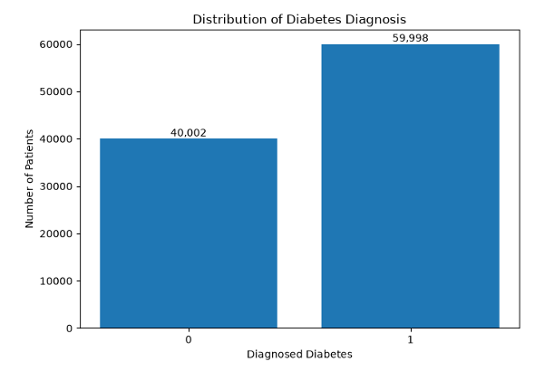
Interpretation: The dataset contains more diabetes-positive observations than diabetes-negative observations. Consequently, accuracy alone is insufficient for judging whether the model identifies positive cases effectively.

Data types
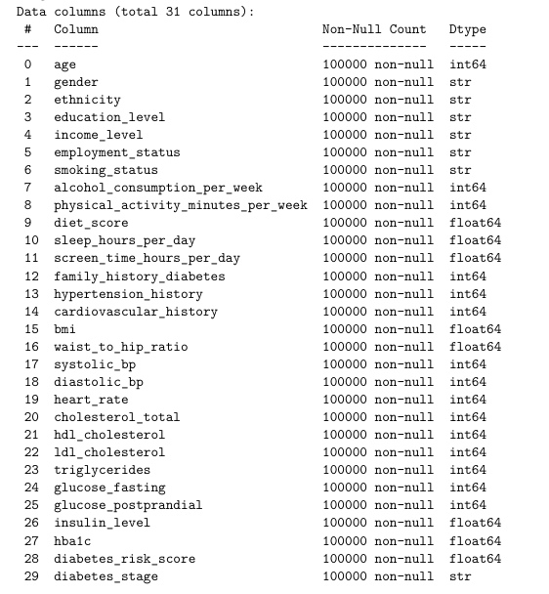
After feature selection, the predictive variables consist of:
+ 22 numerical features
+ 6 categorical features
This distinction directly determines the preprocessing design used later in the pipeline.

Duplicate analysis
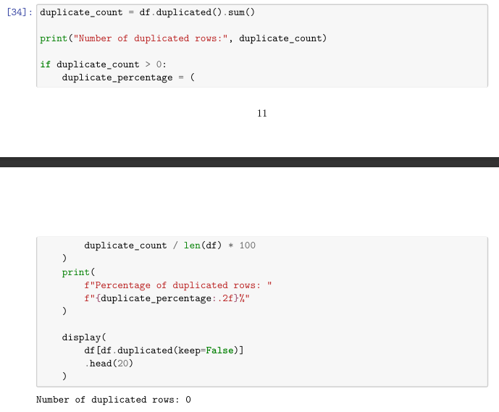
=> The duplicate check found is exact 0 duplicated rows. Therefore, no duplicate removal was required.

Missing values
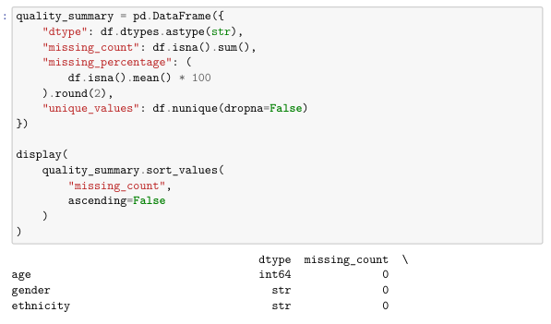
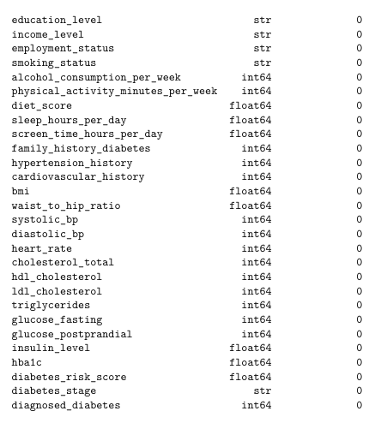
The raw dataset contains no missing values in the inspected columns. Nevertheless, the final preprocessing pipeline retains imputers so that the deployed system remains robust to missing values in future unseen inputs.
=> The numerical branch uses median imputation, while the categorical branch uses most-frequent imputation.

Invalid values
Domain checks identified potentially invalid observations in several clinical variables. The most notable cases were:
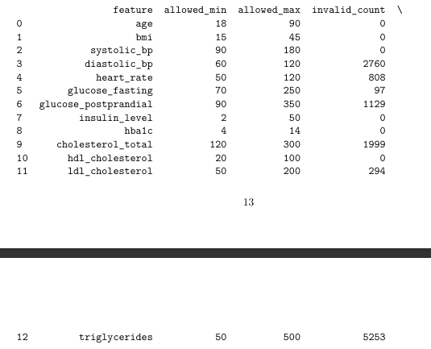
No invalid observations were detected for age, BMI, insulin level, HbA1c, or HDL cholesterol under the selected domain rules.
=> These values were treated as data-quality findings rather than automatically deleted observations. This avoids assuming that every extreme value represents an error.
Outlier analysis
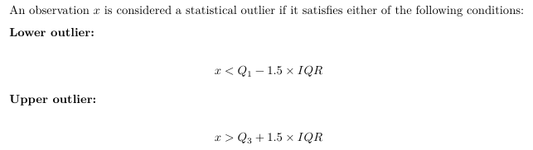
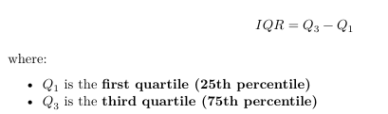
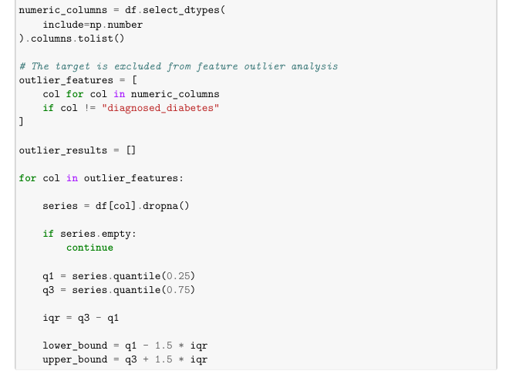
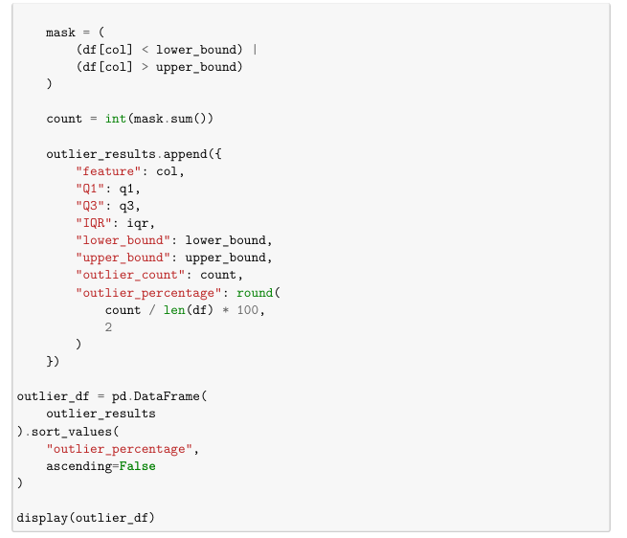
Outliers were examined using the IQR-based method. The analysis was used primarily to understand extreme observations and assess whether they could plausibly represent genuine patient variation. The notebook therefore does not perform indiscriminate outlier removal.
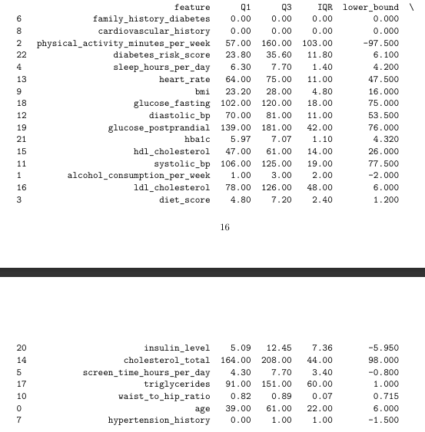

4 Data Cleaning
The cleaning process focused on preparing a reliable feature set while avoiding unnecessary alteration of the original observations.
First, there were no duplicated rows and no missing values requiring removal. Second, identifier-column analysis found no obvious patient-ID column requiring exclusion.
Third, potentially invalid measurements were explicitly identified using predefined domain ranges. These checks were used to assess data quality rather than automatically discarding observations, since an unusual measurement may still carry useful predictive information.
Finally, two variables strongly associated with the diagnosis itself were excluded from the predictive representation. This step is important because including target-derived information could allow the classifier to exploit information that would not be legitimately available at prediction time.
After cleaning and feature selection, the resulting predictive data contain 28 original features.

5 Data Representation
The representation process follows:
$$\text{CSV}→\text{DataFrame}→\text{Selected Feature Matrix}→\text{Encoded/Scaled Matrix}→\text{Model Input}.$$
For a single patient:
$$x_{i}∈R^{28}$$
before preprocessing.
For the complete predictive dataset:
$$X∈R^{100000×28}.$$
The 28 original features consist of 22 numerical and 6 categorical variables.

Numerical representation
Numerical features are passed through a pipeline containing:
$$\text{Median Imputation}→\text{Standardization}.$$
StandardScaler transforms the numerical features to a standardized scale.
Categorical representation
Categorical variables are transformed using:
$$\text{Most-Frequent Imputation}→\text{One-Hot Encoding}.$$
For example, if a categorical variable contains three categories:
$$\left\{A , B , C\right\}$$
one-hot encoding represents them as:
$$A=\left[1 , 0 , 0\right] \\ B=\left[0 , 1 , 0\right] \\ C=\left[0 , 0 , 1\right].$$
This converts categorical information into numerical values without imposing an artificial ordinal relationship between categories. The implementation uses handle_unknown="ignore" so that previously unseen categorical values do not cause the deployment pipeline to fail.
Final model representation
The preprocessing pipeline was fitted only on the training data and then reused to transform the validation and test sets. This produced:
$$X_{train}∈R^{70000×46} \\ X_{validation}∈R^{15000×46} \\ X_{test}∈R^{15000×46}.$$
Therefore:
$$d_{original}=28$$
and:
$$d_{final}=46.$$
The increase from 28 to 46 dimensions results from the expansion of categorical variables through one-hot encoding.
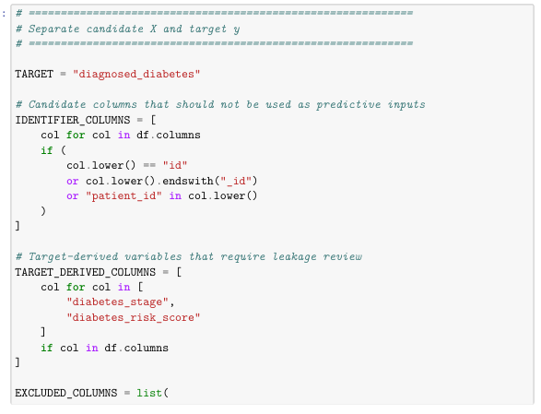
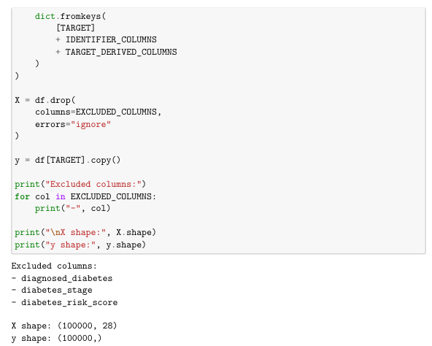
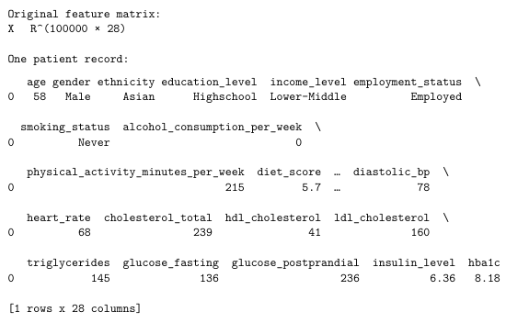
Final numerical representation
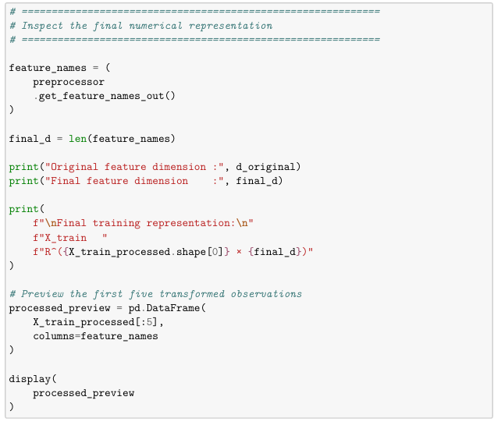
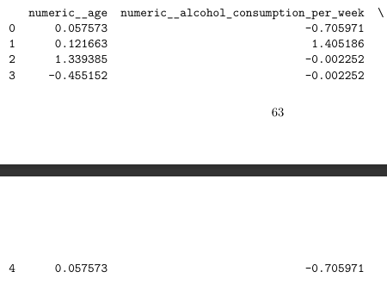
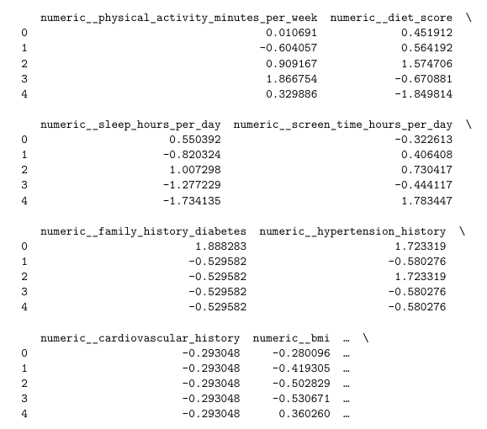
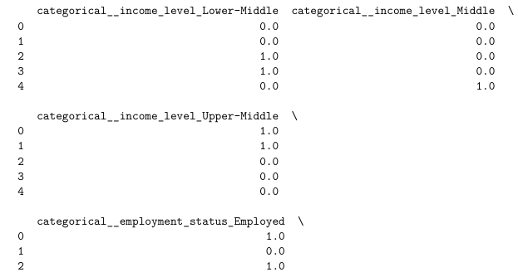

6. Exploratory Data Analysis
Exploratory analysis examined target distribution, numerical feature distributions, feature–target relationships, categorical distributions, pairwise relationships, and correlations.
Target distributions
Numerical feature distributions
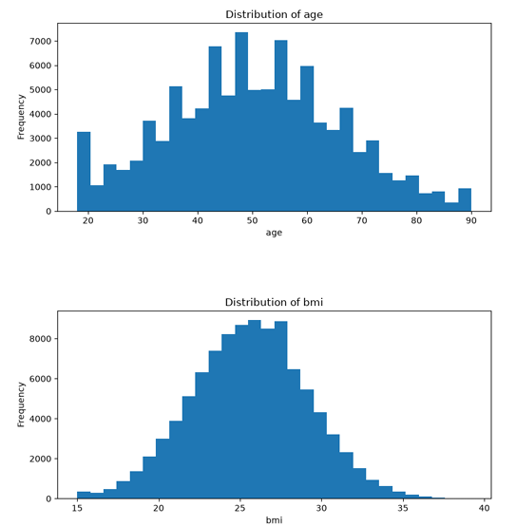

Feature–target relationships
Numerical variables were also compared across diabetes classes using box plots and violin plots.
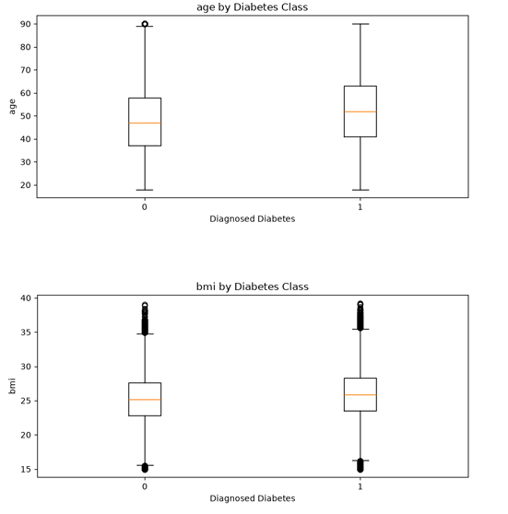
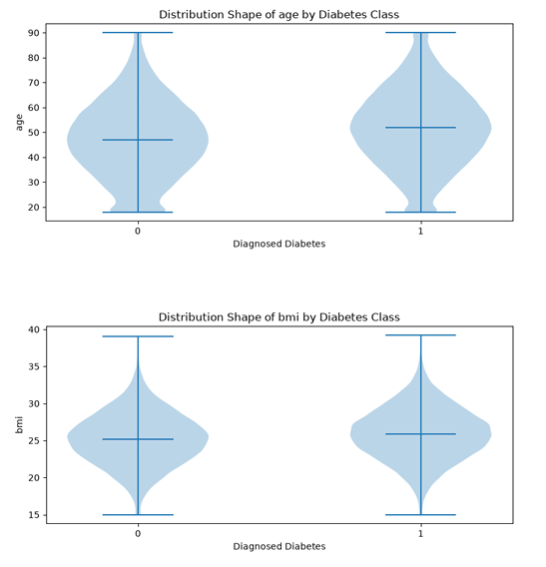
Categorical features across diabetes classes
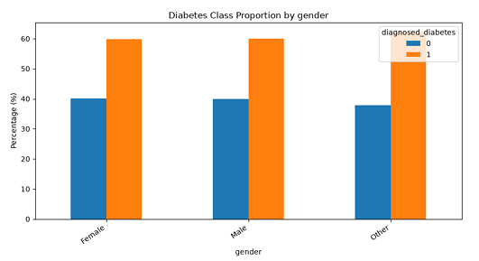
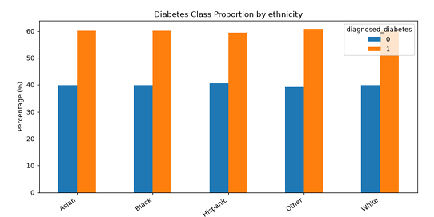
Relationships between important features
The notebook additionally examines relationships such as:
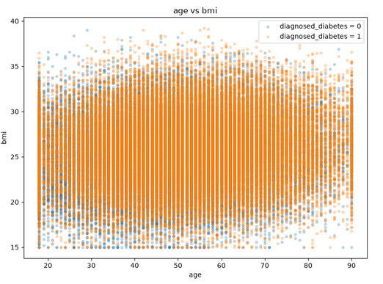
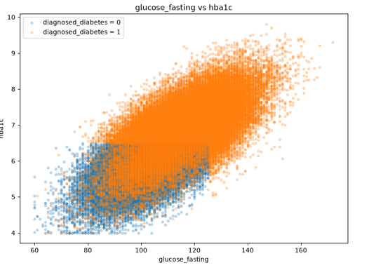
Overall, the EDA indicates that the dataset contains substantial information relevant to diabetes classification, particularly across clinical and metabolic measurements.
7 Model Development
The data were divided into training, validation, and test subsets using a 70/15/15 stratified split:
Dataset | Rows
Training | 70,000
Validation | 15,000
Test | 15,000
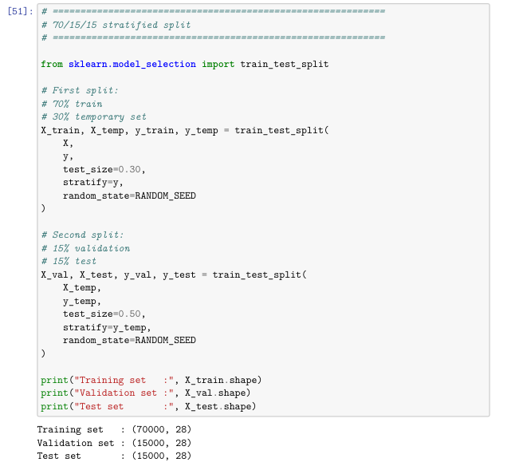
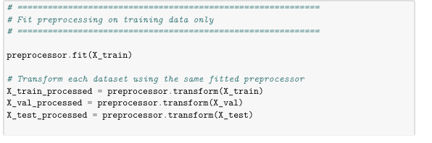
The preprocessing object was fitted only on the training set. The validation set was used for model comparison and hyperparameter experiments, while the test set remained untouched until the final evaluation.

Baseline model
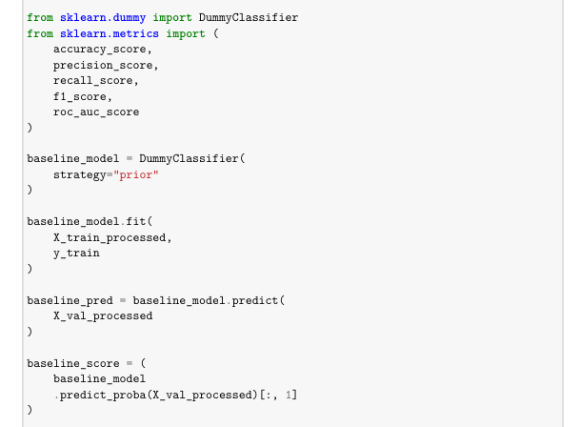
A DummyClassifier was used as a non-learning baseline. Its validation results were approximately:
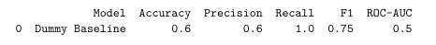
The baseline provides a reference point against which the learning-based classifiers can be evaluated.

Classification models
Five classifiers were trained:
- Logistic Regression
- KNN
- Decision Tree
- Random Forest
- SVM
The models represent different learning assumptions, including linear, distance-based, tree-based, ensemble, and kernel-based approaches.
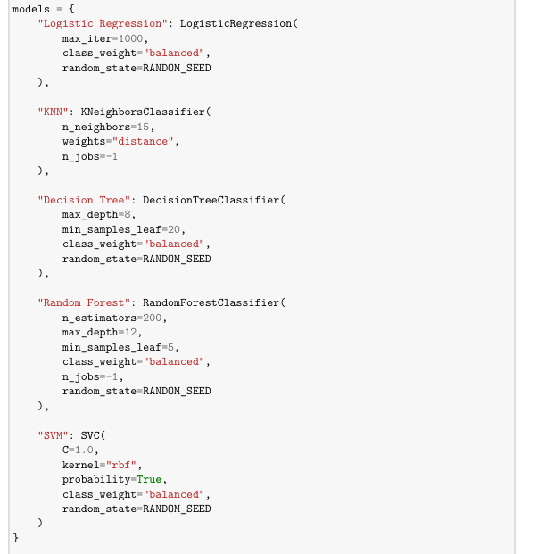
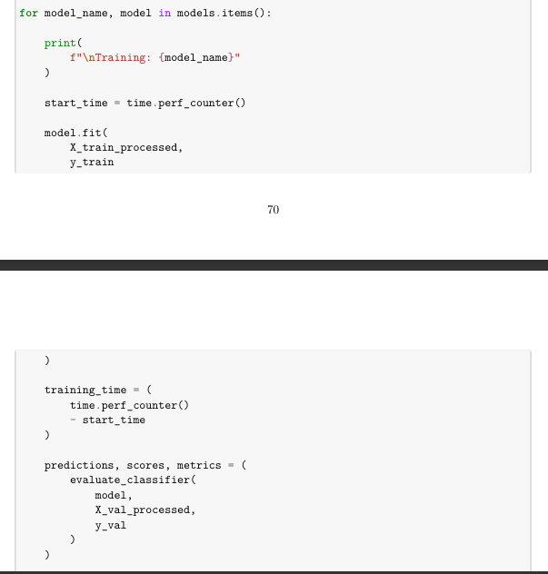

Hyperparameter experiments
Three focused experiments were conducted.
Experiment 1 — Logistic Regression
How does the regularization strength $C$affect validation performance?
The values:
$$C∈\left\{0.01 , 0.1 , 1 , 10\right\}$$
were evaluated. The best F1 result occurred at:
$$C=1$$
with F1 = 0.904574.
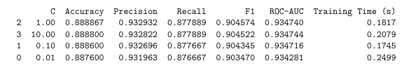
Experiment 2 — Random Forest
Does increasing the number of trees improve predictive performance enough to justify the additional computational cost?
The values:
$$n_{estimators}∈\left\{50 , 100 , 200 , 300\right\}$$
produced identical accuracy, precision, recall, and F1 values, while training time increased from 0.9076 seconds at 50 trees to 7.9661 seconds at 300 trees. ROC-AUC improved only marginally.
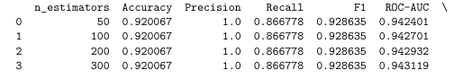
Experiment 3 — Decision Tree
How does tree depth affect the balance between model complexity and predictive performance?
The evaluated values were:
$$max_depth∈\left\{3 , 5 , 8 , 12 , 16\right\}.$$
The shallow trees at depths 3 and 5 produced the highest F1 of 0.928635, while deeper trees did not improve F1 and increased training time.
These experiments show that increasing model complexity does not automatically produce a meaningful performance improvement.
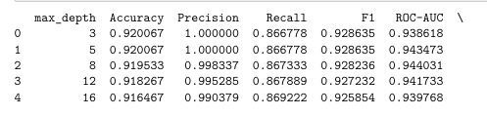
8 Evaluation
The models were evaluated using Accuracy, Precision, Recall, F1-score, ROC-AUC, and training time.
Model comparison
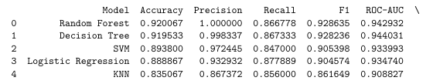
Random Forest achieved the highest F1-score and accuracy, while Decision Tree achieved slightly higher recall and ROC-AUC. SVM delivered good predictive performance but required substantially more computational time.
Evaluation metrics
For this medical classification task, Recall is especially important because a false negative corresponds to a diabetes-positive patient that the classifier fails to identify. However, maximizing Recall alone is undesirable because excessive false positives reduce Precision.
F1-score therefore provides a useful balance between Precision and Recall, while ROC-AUC provides an additional view of the classifier's class-separation capability.
9 Model Selection
The deployment candidate was selected using a combined ranking of:
- F1-score;
- Recall;
- ROC-AUC.
The ranking was:
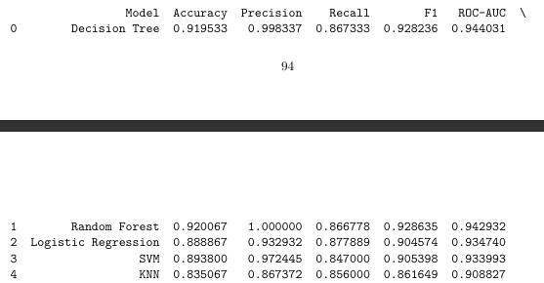
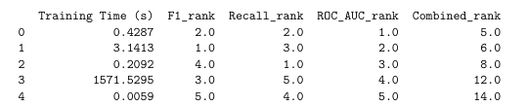 The Decision Tree was therefore selected as the final deployment model.
Random Forest obtained a marginally higher F1-score ,but the Decision Tree achieved a better combined ranking because it provided competitive F1, higher Recall and ROC-AUC, and considerably lower training cost. Its simpler structure also provides better interpretability and is more convenient for deployment.
The final model configuration used for persistence is:
DecisionTreeClassifier(
max_depth=8,
min_samples_leaf=20,
class_weight="balanced",
random_state=42
)
The final test performance confirms that the selected model generalizes closely to the held-out observations, with a test F1 of 0.928758 and ROC-AUC of 0.942061.
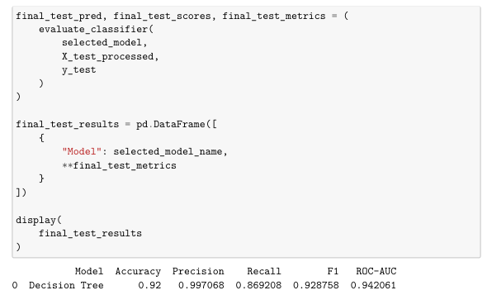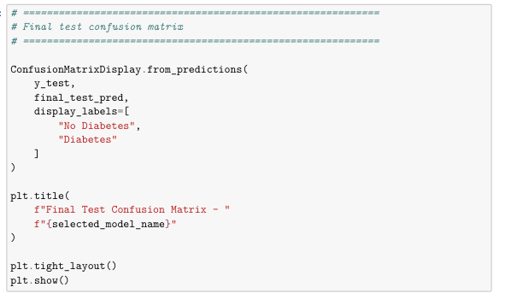
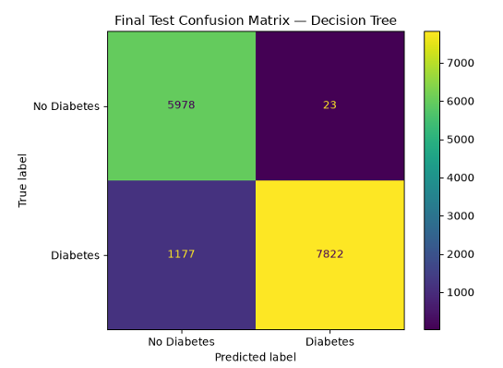

10 Deployment
The selected Decision Tree was combined with the fitted preprocessing pipeline into a complete machine-learning pipeline.
The pipeline was trained on the training data and persisted as:
model/diabetes_model_pipeline.joblib
The same artifact contains preprocessing and the final classifier, ensuring consistency in:
- imputation;
- categorical encoding;
- scaling;
- feature ordering;
- model inference.
Reproducibility metadata were additionally stored in:
model/metadata.json
including dataset information, selected model, random seed, environment information, split sizes, and feature dimensions.

Web Service
The prediction service is implemented using Flask.
The main prediction endpoint is:
POST /diabetes/v1/predict
The inference workflow is:
$$\text{Patient Input}→\text{Validation}→\text{Preprocessing}→\text{Decision Tree}→\text{Prediction}.$$
The service returns the predicted diabetes class together with probability and confidence information.
The Web interface provides:
- patient information input;
- numerical and categorical controls;
- sample data for testing;
- prediction submission;
- diagnosis;
- confidence;
- diabetes probability;
- no-diabetes probability;
- selected model information.
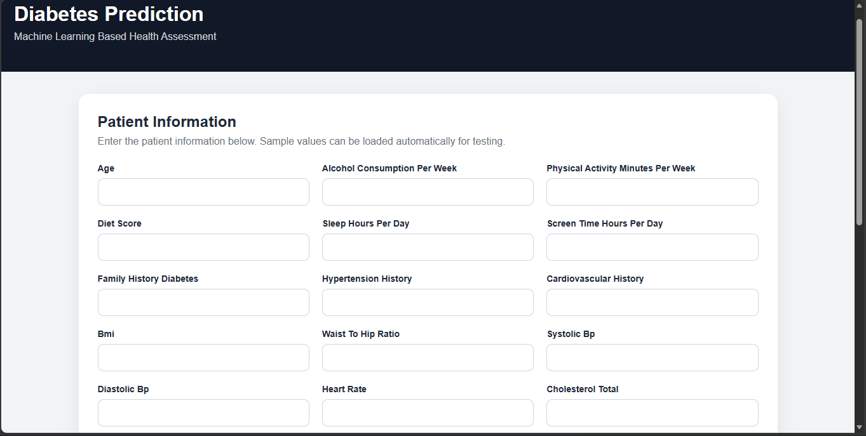
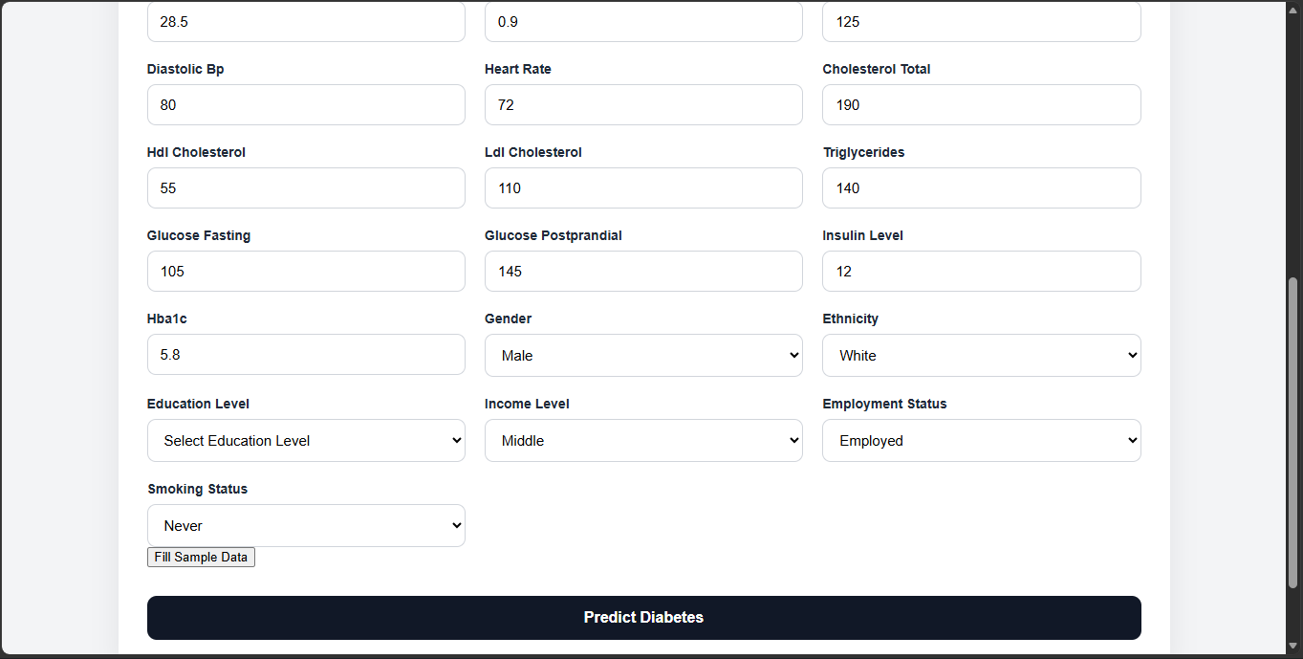
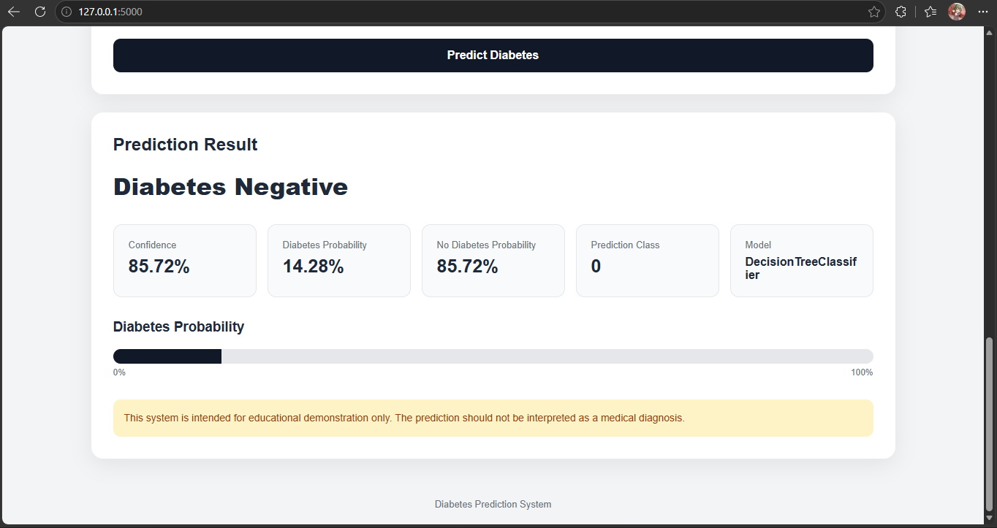
Mobile Application
The mobile client was implemented using Android Studio, Kotlin, and Jetpack Compose. It communicates with the same Flask prediction service rather than embedding the trained model inside the Android application.
The architecture is:
$$\text{Mobile UI}→\text{REST API}→\text{Saved Preprocessing}→\text{Saved Model}→\text{Prediction}→\text{Mobile UI}.$$
The mobile interface dynamically obtains the model schema, provides patient-input controls, supports sample data, and displays the returned diagnosis and probability information.
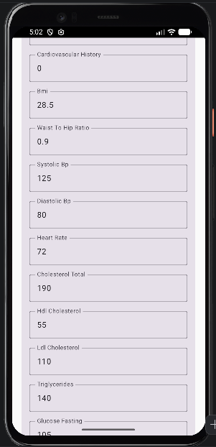
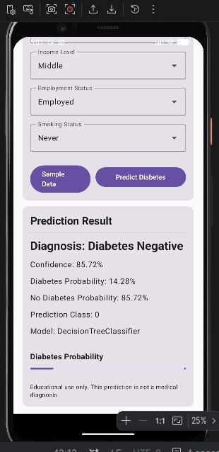
that the saved preprocessing/model pipeline can be reused for inference independently of the training process.

B. Application 2 — House Price Prediction
1 Problem Description
House price prediction is formulated as a supervised regression problem. The objective is to estimate the historical price of a property from information that describes the property and its geographical location.
The problem is defined as:
$$X=\text{house characteristics} \\ y=\text{house price}$$
where each row represents one property transaction record and the target variable is history_price.
The prediction problem is challenging because house prices are influenced by several factors at the same time. Property size and room count provide information about the physical characteristics of a property, while latitude, longitude, outcode and related location attributes capture geographical differences in the London housing market. The dataset also contains properties with very different price levels, including a relatively small number of very high-value transactions. This creates a strongly skewed target distribution and makes large prediction errors particularly important.
The system is designed around the following pipeline:
$$\text{Raw Data}→\text{Cleaning}→\text{Representation}→\text{Regression Model}→\text{Prediction}$$
The objective is not only to obtain a strong predictive model, but also to produce a representation that can be consistently reused during deployment.
2 Dataset
The dataset used in this application is the London House Price Data available from Kaggle. The dataset contains property characteristics, location information, transaction history and price-related variables.
The local notebook loads 418,201 observations with 28 original columns.
The target variable is:
history_price
The main predictive variables used in the current experiment include:
Feature | Type | Description
latitude | Numerical | Geographic latitude
longitude | Numerical | Geographic longitude
outcode | Categorical | Broad postcode area
bathrooms | Numerical | Number of bathrooms
bedrooms | Numerical | Number of bedrooms
floorAreaSqM | Numerical | Floor area in square metres
livingRooms | Numerical | Number of living rooms
tenure | Categorical | Property tenure
propertyType | Categorical | Property type
currentEnergyRating | Categorical | Current energy rating
The original dataset also contains detailed address information, postcode, rent estimates, sale estimates and historical variables. The raw dataset contains 137,760 distinct full addresses and 48,392 distinct postcodes, showing that these fields have very high cardinality.
For the prediction problem, location remains an important part of the representation. The structured geographical variables latitude, longitude and outcode are therefore retained rather than treating location as irrelevant information.
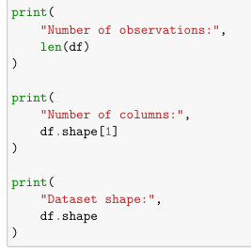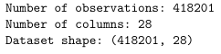
3 Data Understanding and Cleaning
Before model development, the dataset was examined to identify missing values, duplicate records, invalid observations, outliers and variable types.
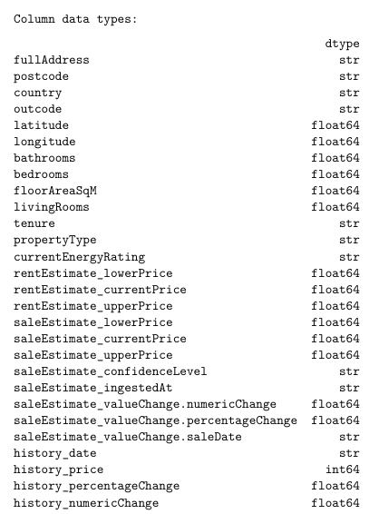

Missing values
Missing values are present in several property attributes. The largest missing proportions include currentEnergyRating, bathrooms, livingRooms, bedrooms, floorAreaSqM and tenure. The historical change variables also contain substantial missingness.
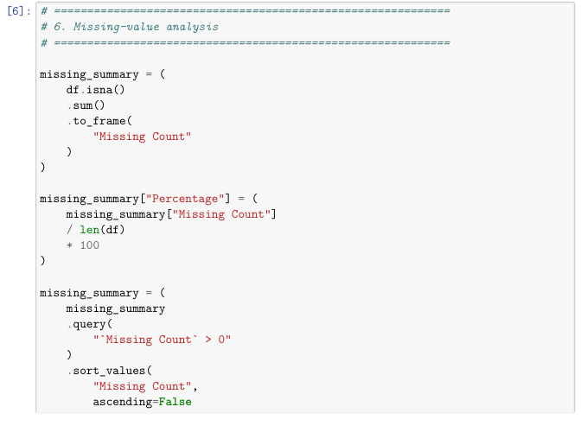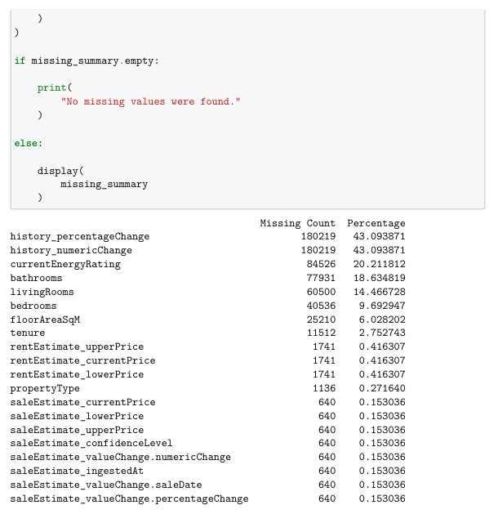
Instead of deleting all rows containing missing values, the model pipeline handles missing values according to feature type.
=> Numerical variables are imputed using their median values, while categorical variables are filled using the most frequent category. This approach preserves a much larger proportion of the dataset while keeping the transformation consistent between training and inference.
Duplicate records
The dataset contains seven exact duplicate rows.
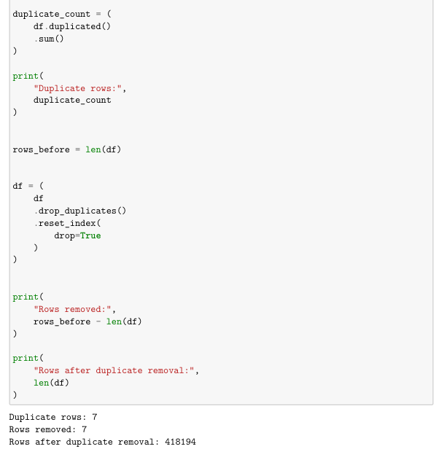
These duplicates are removed before model development because repeated copies of exactly the same observation can give those records a disproportionate influence during training.
Invalid values
Invalid values are treated differently from statistical outliers. A high house price may be unusual, but it is not necessarily incorrect. In contrast, a non-positive house price or a negative room count would violate the basic meaning of the variable.
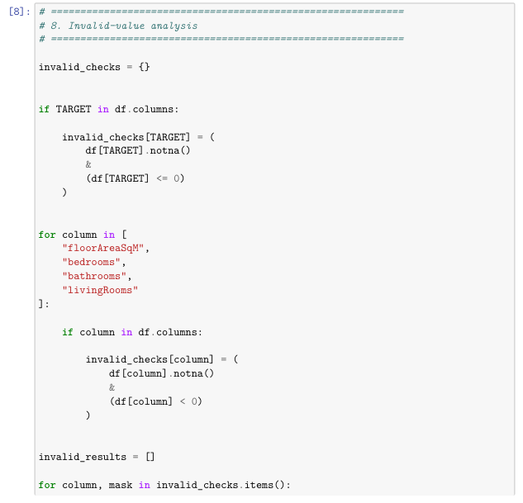
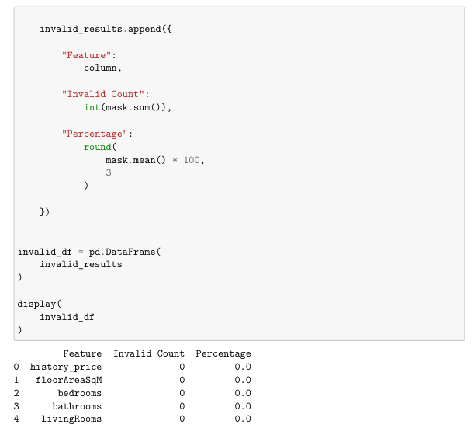
The notebook checks for non-positive prices and negative values in the main property measurements. No such invalid records were identified, so no observations were removed for this reason.
Outliers
The target variable is highly right-skewed. The mean historical price is approximately £639,584, while the median is £400,000 and the maximum is above £105 million.
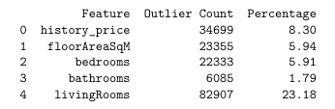
This difference indicates a long upper tail. The extreme values are therefore important for model evaluation even though they should not be removed automatically. In a real property market, expensive properties are legitimate observations and removing them simply because they are statistically extreme could distort the task.
Feature-selection consideration
The dataset contains several fields that are not suitable as direct model inputs for the intended prediction scenario. Detailed address strings are highly specific, while current estimate fields describe other valuation outputs rather than the core property characteristics used by the application.

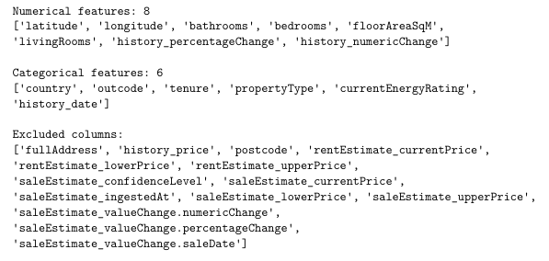
4 Representation
The representation is constructed through four stages:
$$\text{Raw CSV}→\text{DataFrame}→\text{Clean Feature Set}→\text{Encoded and Scaled Model Input}$$
For one property:
$$x_{i}={\left[x_{i1} , x_{i2} , … , x_{id}\right]}^{T}$$
For the full dataset:
$$X=\left[\begin{matrix}x_{1}^{T} \\ x_{2}^{T} \\ ⋮ \\ x_{N}^{T}\end{matrix}\right]∈R^{N×d}$$
and the target is:
$$y∈R^{N}$$
The original data contains 418,201 observations and 28 columns. After duplicate removal, 418,194 observations remain for the modelling workflow.
In the current notebook, the engineered representation contains 16 features before encoding. After preprocessing, the training representation contains 205 numerical dimensions.
Numerical representation
Numerical variables are converted into a common scale using standardization:
$$z=\frac{x-μ}{σ}$$
where the mean and standard deviation are learned from the training data.
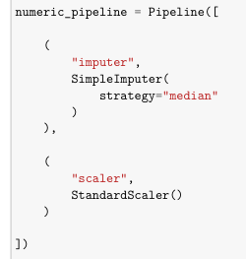
Categorical representation
Categorical variables are converted into binary numerical features using one-hot encoding. For example, a property type with several possible categories is represented by a corresponding set of indicator variables.
Unknown categories are ignored during transformation so that a previously unseen category does not cause the deployed service to fail.
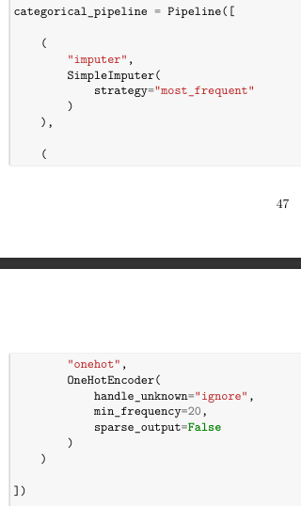
What information is preserved?
The representation preserves information about:
- property size
- number of rooms
- geographical position
- property type
- tenure
- energy rating
The most important loss occurs when raw textual information is converted into structured numerical variables. A full address is not preserved as a raw sentence, but its useful geographical information can still be represented through structured location features.
What is the final model input?
After preprocessing, the categorical variables are expanded into one-hot dimensions and numerical variables are standardized. The result is a dense numerical matrix that can be passed directly to the regression models.

5 Exploratory Data Analysis
Exploratory analysis was used to understand both the target distribution and the relationships between property characteristics and price.
House-price distribution
The historical price distribution is strongly right-skewed. Most observations are concentrated at relatively moderate prices, while a much smaller number of properties have extremely high values.
This matters because the regression problem is not balanced across the target range. A model can perform reasonably well for typical properties while still making very large errors for premium properties.
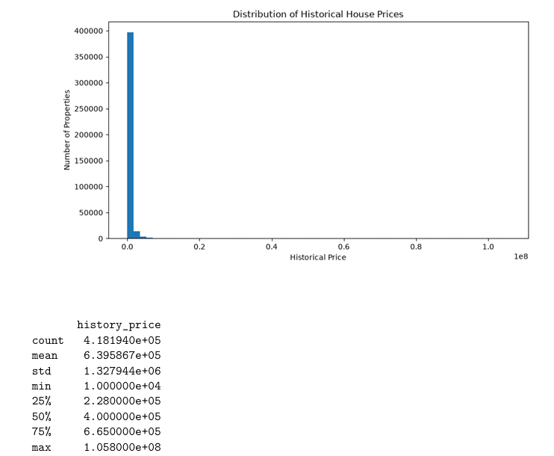
Property characteristics and price
Floor area shows a clear positive relationship with historical price. Larger properties generally tend to command higher prices, although the relationship is not perfectly linear.
Room-related variables such as bedrooms, bathrooms and living rooms also show positive relationships with price. Their effect is less direct than floor area because the same number of rooms can occur in properties with very different sizes and locations.
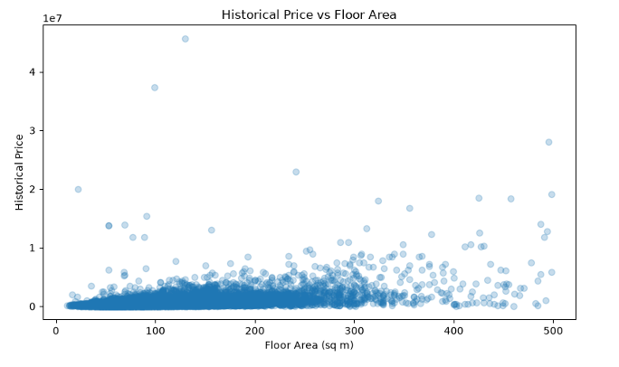
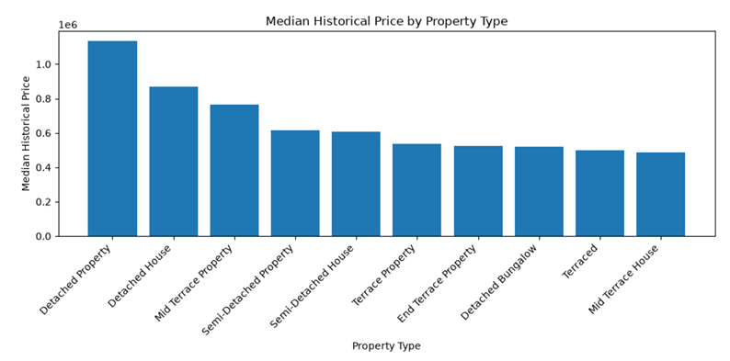

Correlation analysis
The correlation matrix shows that floor area has the strongest positive linear relationship with historical price among the numerical property variables. Room-related variables also have positive associations with price, while the geographical coordinates have weaker linear correlations.
Correlation should not be interpreted as a complete description of feature importance. A weak linear correlation does not imply that a variable has no predictive value, particularly when its relationship with the target is nonlinear.
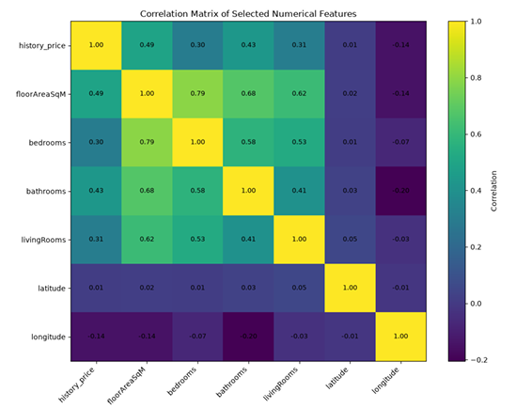
ML implication
The EDA provides a practical explanation for the model selection. Price is influenced by multiple interacting variables, the target is highly skewed, and some relationships are clearly nonlinear. These characteristics make it reasonable to compare linear regression with nonlinear tree-based ensemble methods.
6 Regression Models
Five regression models were developed and compared:
- Linear Regression
- Ridge Regression
- Decision Tree Regressor
- Random Forest Regressor
- Gradient Boosting Regressor
Linear Regression provides a simple baseline for modelling the relationship between the features and the target. Ridge Regression extends this approach by introducing regularisation. Decision Tree provides a nonlinear model based on recursive splits, while Random Forest and Gradient Boosting combine multiple trees to obtain more expressive predictive functions.
The models were trained using the same processed feature representation so that the comparison reflects differences in modelling behaviour rather than differences in preprocessing.
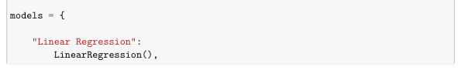
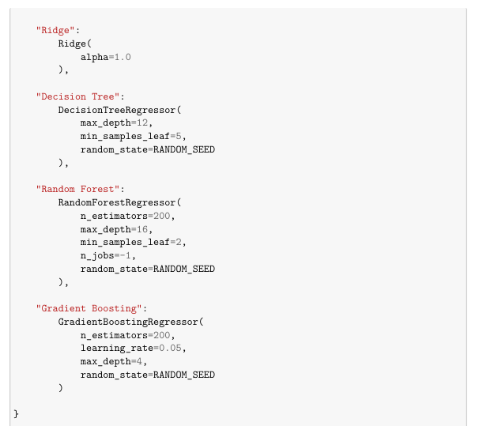
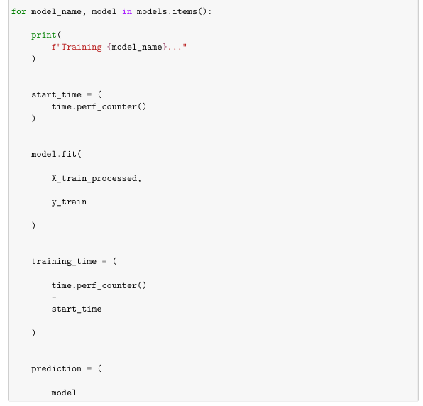
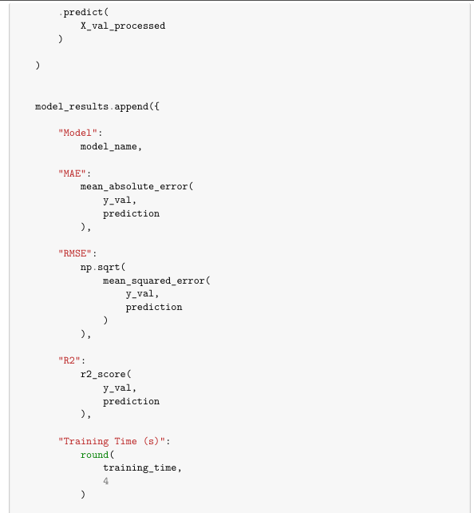
The current validation results are:
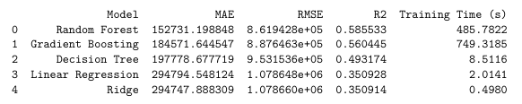
The results show that the nonlinear tree-based models outperform the two linear models. This supports the conclusion from EDA that house prices cannot be adequately described by a simple linear relationship over the available variables.
A notable result is that Random Forest achieves the lowest MAE, while Gradient Boosting achieves the lowest RMSE and the highest R². This difference becomes important in the final model-selection decision.
7 Evaluation
Mean Absolute Error
$$MAE=\frac{1}{N}\sum_{i=1}^{N}{∣}y_{i}-{\hat{y}}_{i}∣$$
MAE represents the average absolute difference between the actual price and the predicted price. Because it is expressed in pounds, it has a direct practical interpretation. A lower MAE means that the model is closer to the actual price on average.
Mean Squared Error
$$MSE=\frac{1}{N}\sum_{i=1}^{N}{(}\left.y_{i}-{\hat{y}}_{i}{\left.)\right.}^{2}\right.$$
MSE gives greater weight to large errors because the residual is squared.
Root Mean Squared Error
$$RMSE=\sqrt{MSE}$$
RMSE is expressed in pounds, making it easier to interpret than MSE. It is especially useful here because a small number of very large house-price errors can have a significant effect on model quality.
R²
R² measures the proportion of variance in the target that is explained by the regression model.
The selected model currently achieves:
$$R^{2}=0.6239$$
on the validation set. This indicates that the model explains approximately 62.4% of the observed variation in the validation prices.
Which model performed best?
The current validation results identify Gradient Boosting Tuned as the strongest overall model under the chosen selection criterion. It has the lowest RMSE and the highest R² among the five candidates.
Random Forest has a lower MAE, meaning its average absolute error is smaller. However, its higher RMSE indicates that it makes larger individual errors more often or with greater magnitude.
Why was Gradient Boosting selected?
The model was selected using validation RMSE. This decision is intentional rather than arbitrary. The target distribution contains very expensive properties, and large prediction errors on such observations are important. RMSE penalises these large errors more heavily than MAE.
The notebook explicitly follows the principle that model selection should be performed using the validation data while the test set remains isolated until the final evaluation.
Error analysis
The model performs substantially better for the central portion of the price distribution than for extreme high-value properties. The largest residuals occur when very expensive properties are predicted at much lower prices than their actual values.
This behaviour is visible in the actual-versus-predicted scatter plot. A strong model would place observations close to the diagonal line:
$$\hat{y}=y$$
Large vertical deviations from the diagonal correspond to large prediction errors.
The result suggests that the main limitation is not a complete failure to identify normal property prices, but difficulty modelling the relatively rare upper tail of the market.
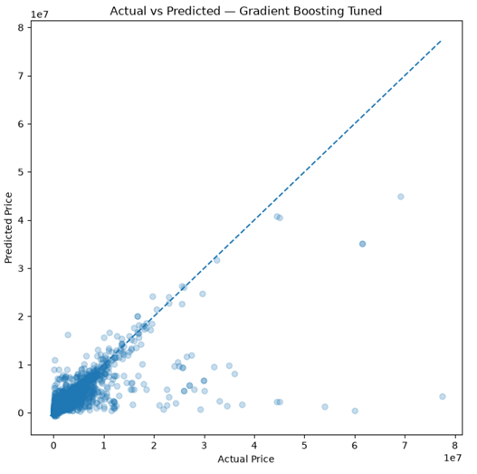

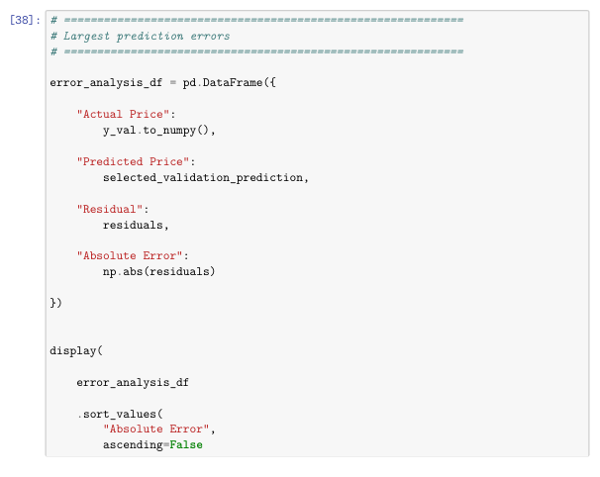
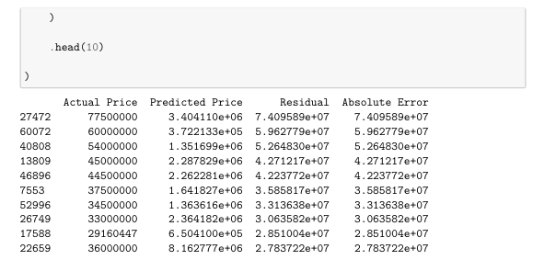
8 Deployment
The final model is deployed as both a web application and a mobile application
The deployment architecture follows:
$$\text{User Input}→\text{Validation}→\text{Preprocessing}→\text{Saved Model}→\text{Prediction}$$
The same preprocessing logic used during training is preserved with the model so that raw user input is converted into exactly the representation expected by the regression model.
Web deployment
The Web application is implemented with Flask. The service loads the saved model pipeline and performs inference on new property information rather than retraining the model.
The input interface provides the property and location information required by the deployed representation. After validation, the input is passed through the saved preprocessing pipeline and then to the selected regression model.
The main output is:
Predicted House Price
The interface can also display supporting model information such as the selected model and validation performance, but these values describe model performance and should not be presented as a probability that the individual price estimate is correct. 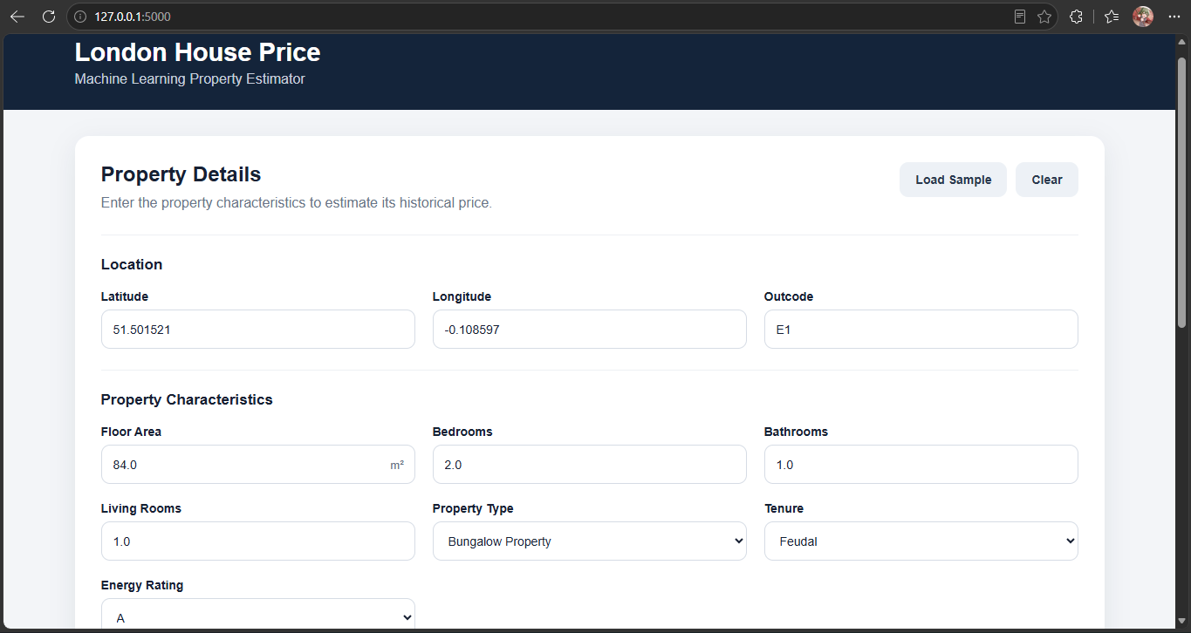
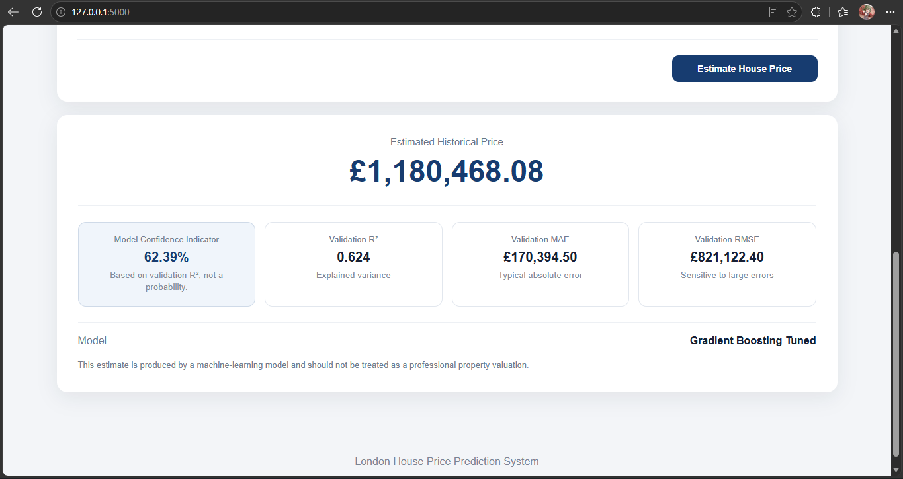

Mobile deployment
The mobile application is implemented using Android and Kotlin. The mobile client does not train or store the regression model locally. Instead, it communicates with the Flask REST service.
The complete workflow is:
$$\text{Mobile UI}→\text{REST API}→\text{Preprocessing}→\text{Saved ML Model}→\text{Prediction}→\text{Mobile UI}$$
This follows the recommended mobile architecture in Assignment 02.
The mobile application allows the user to enter or select the required property characteristics, submit a prediction request and display the resulting estimated house price.
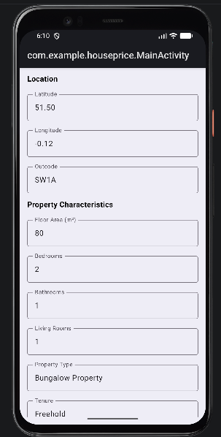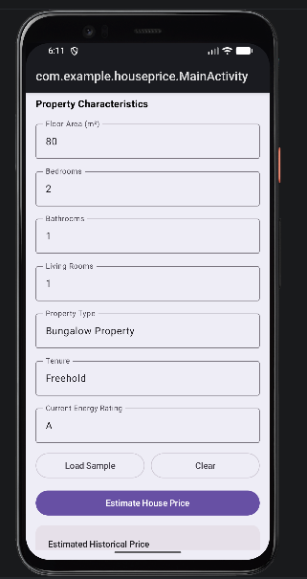
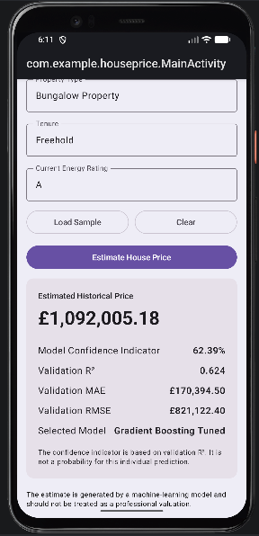
Deployment considerations
A key requirement is consistency between training and inference. If a categorical value is encoded differently, a numerical variable is scaled differently, or the feature order changes, the deployed model will receive a different representation from the one used during training. The prediction can then become unreliable even though the model itself has not changed.
For this reason, the deployment system uses the persisted preprocessing and model together rather than implementing a second, independently written preprocessing procedure. This also allows the Web and Mobile clients to share the same prediction service, reducing duplication and keeping the system architecture consistent.

